PATHSHALA NEPAL FOUNDATION

PRE-UNI PROGRAM

Baneshwor, Kathmandu



Lab Assessment Report on

Data File Management through Programming

**Submitted By:** **Submitted To**

Name: Raunak Raj Adhikari Department of Computer Science

Class: 12 PATHSHALA NEPAL FOUNDATION

Group: 2

Date: 2023-11-28

**2. Answer the following:**

1. Show the differences between data file and program file.
2. Explain briefly about different types of I/O functions used in C with examples.
3. Explain briefly on formatted and unformatted Console I/O functions.
4. Show the Disk I/O function in tree diagram with example.
5. Write syntax and use of the following functions:
   1. getchar()
   2. putchar()
   3. fgets()
   4. fput()
   5. fscanf()
   6. fprintf()
   7. fwrite()

**3. Write Programs: (H/P):**

1. Write a program to create a text file named “info.txt” for the storage of a line of text supplied by a user.

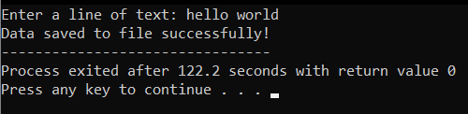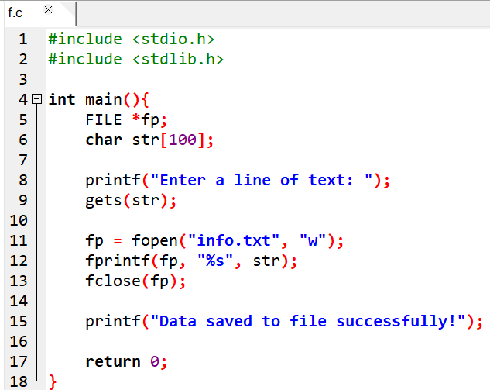

1. Write a program to read the information stored in “info.txt” file (refer question no 1) and display them in upper case.

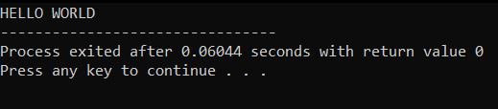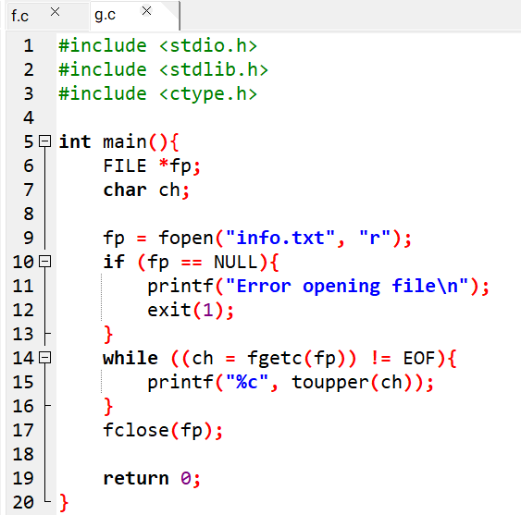

1. Write a program to read any ten integers and store in a text file named “num.txt”. Also read all the numbers from the file and display them with the calculation of their sum.

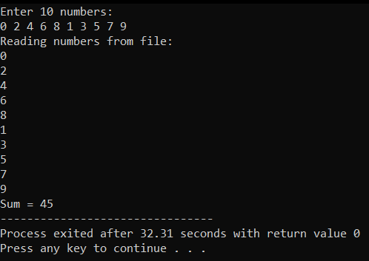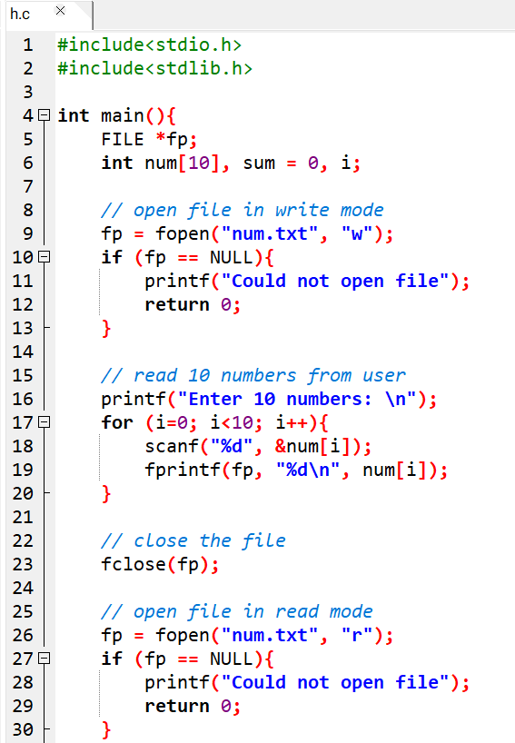

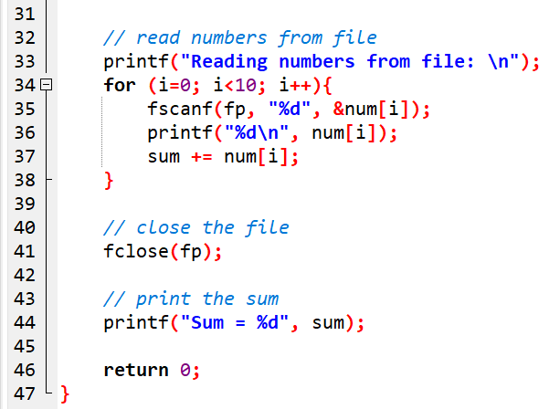

1. Write a program that reads n integers for a file named “integers.txt” and reads every integer from the file to store in “odd.txt” for odd values and “even.txt” for even values and finally prints all the files in the console with proper information.

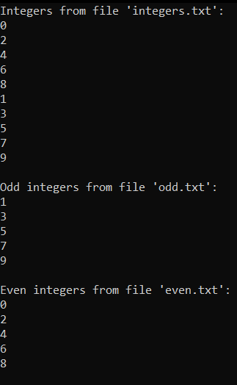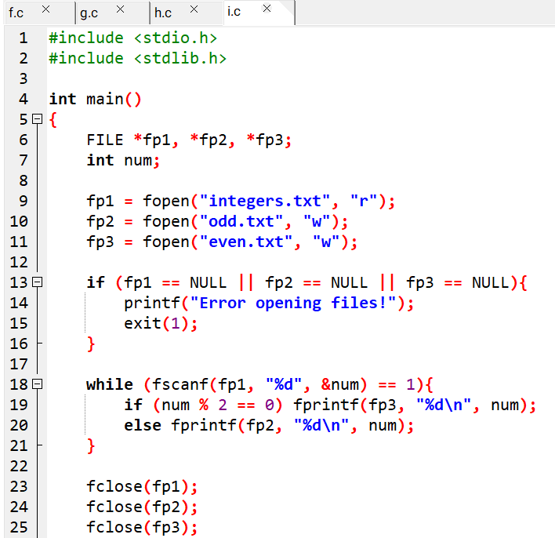 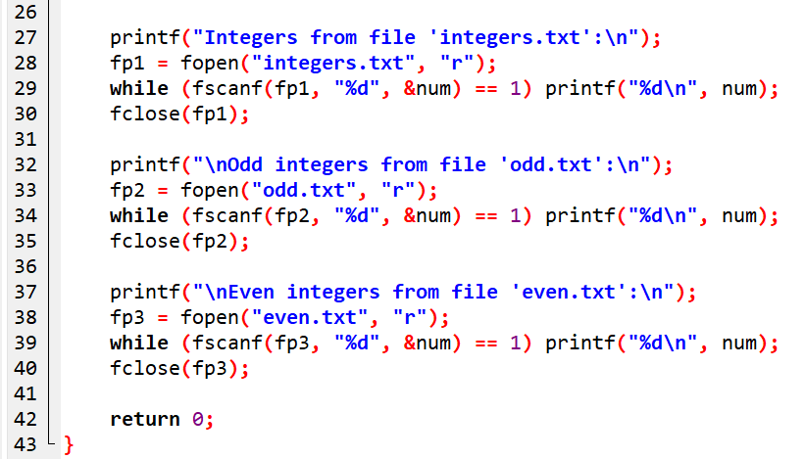

1. Write a program to copy the contents of a text file input by a user to another text file named “textcopy.txt”. Display appropriate message if the source file does not exist.

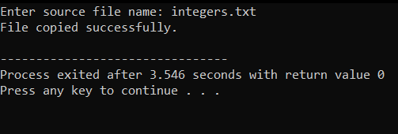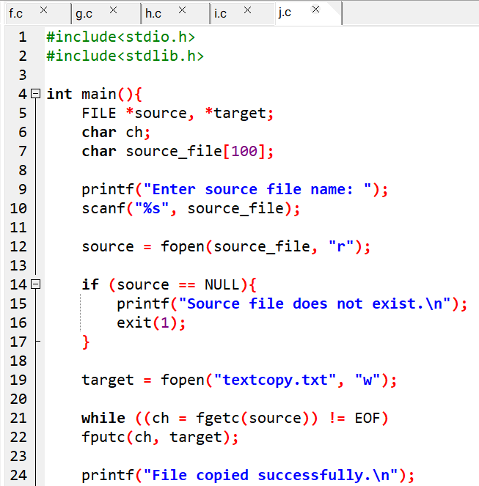

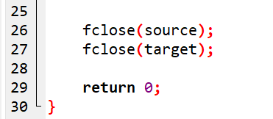

1. Write a program to prompt a user to supply students details such as roll number, name, address, telephone number and store in a text data file named “student.txt”. The program should facilitate the user to continue adding more records or not.

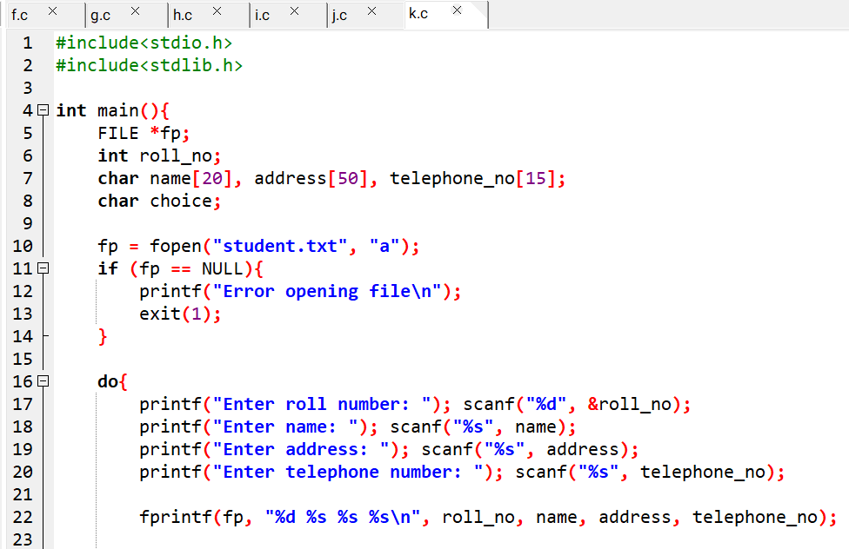 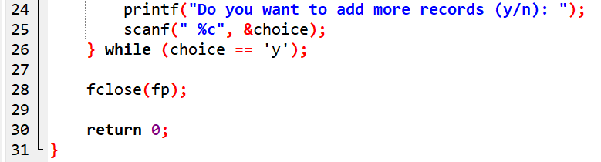

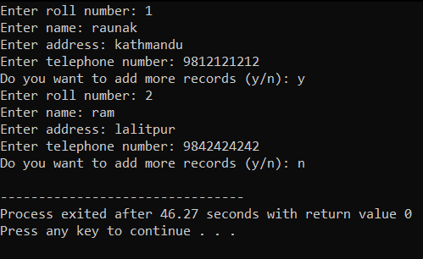

1. Write a program to read data from “student.txt” file which contains student’s information such as roll number, name, address, and telephone number and display them in the proper format.

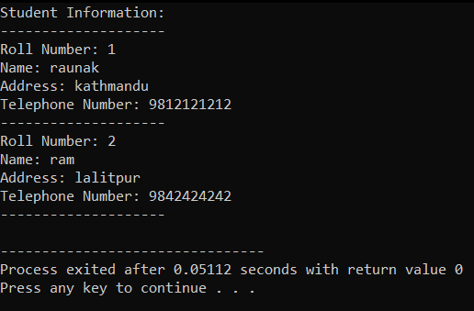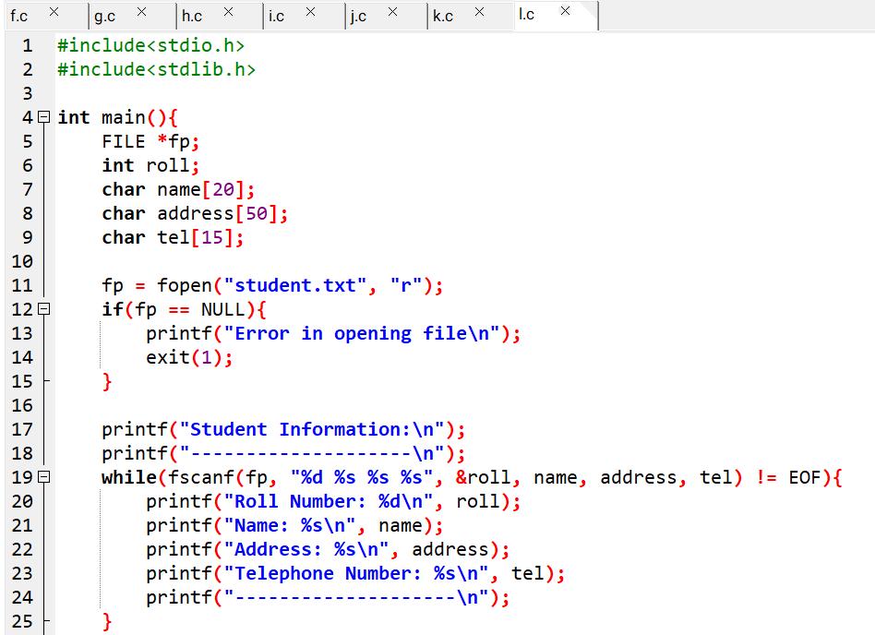 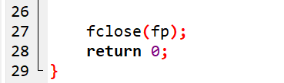

1. Write a program to create a binary file named “studinfo.dat” to store student’s description such as registration number, name and marks scored in five different subjects. The program should facilitate to continue adding more records.

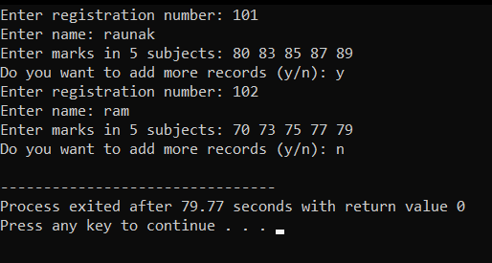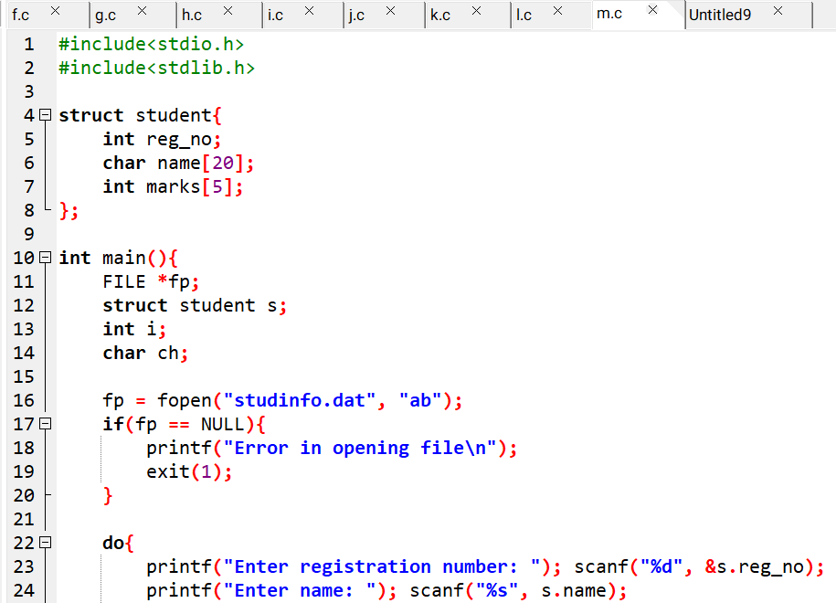

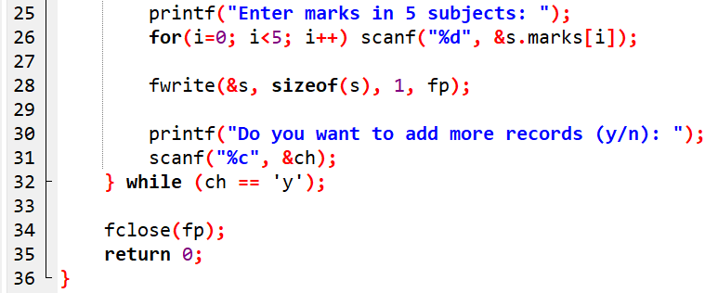

1. Write a program to read records from the binary file named studinfo.dat which contains student’s descriptions such as registration number, name and marks scored in five different subjects and display them in the proper format along with the calculation of total and percentage as well.

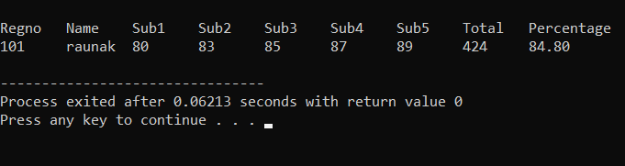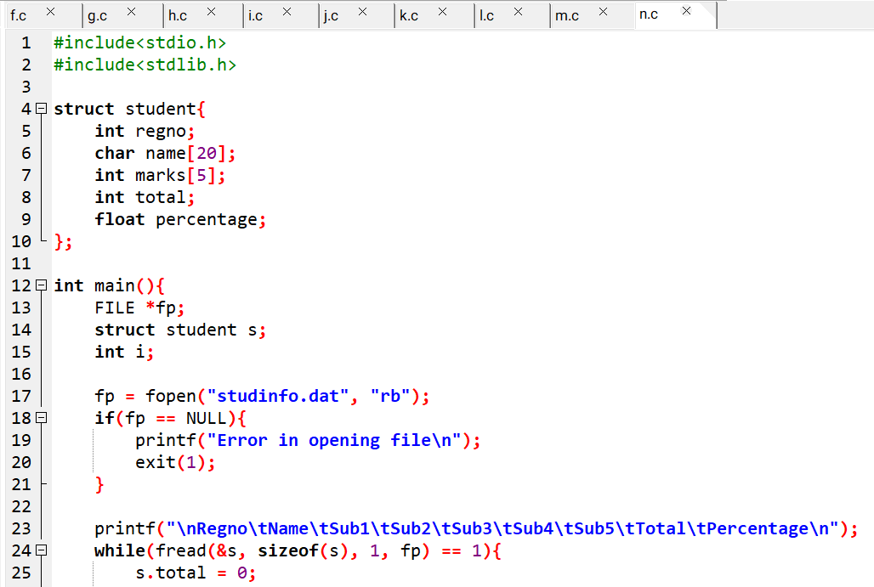 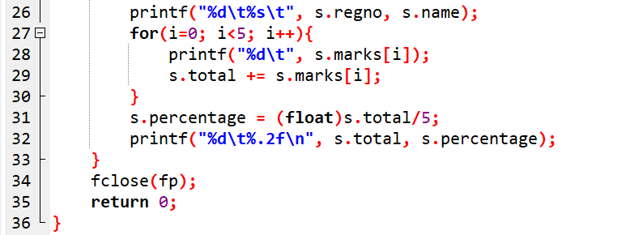

1. Develop a menu driven program to create a sequential data file called employee.dat with the fields emp_code, emp_name, post and salary. The program should work on options as given below:
   1. Add record => to add new records
   2. Display record => to display all the records in the proper format
   3. Search record => to search the records based on emp_code
   4. Delete record => to delete the records based on supplied emp_code
   5. Update record => to change/edit the records
   6. Exit => to exit from the program

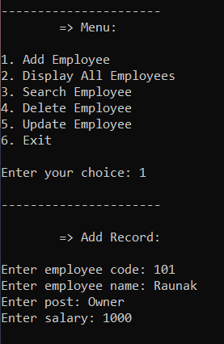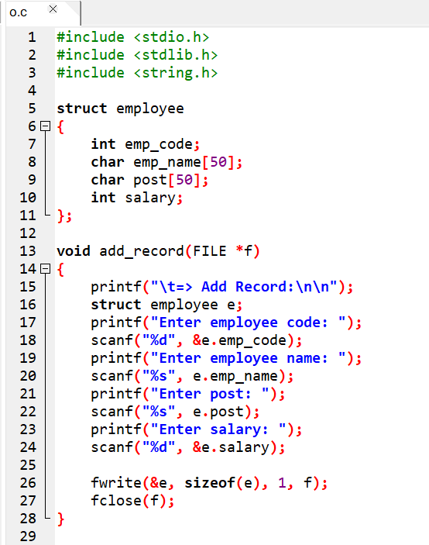

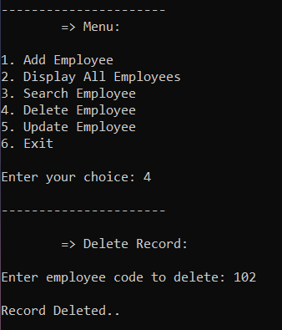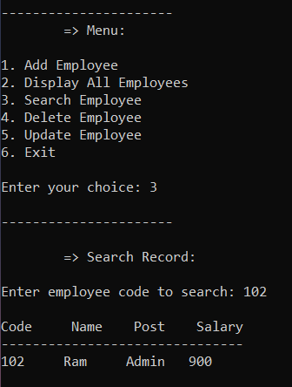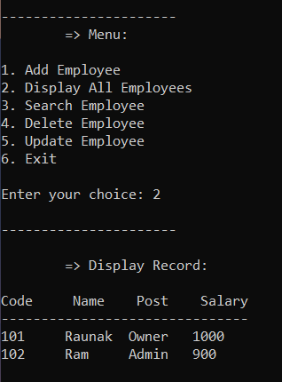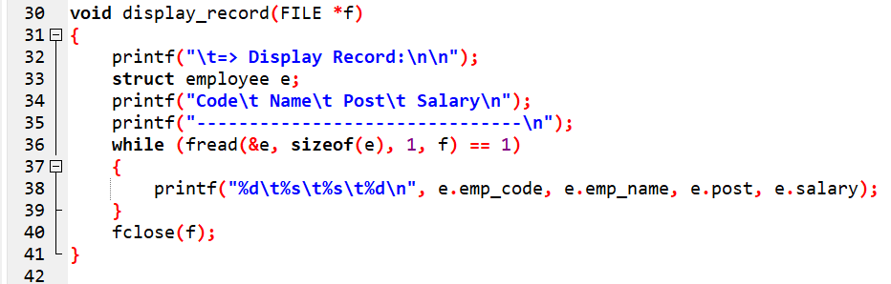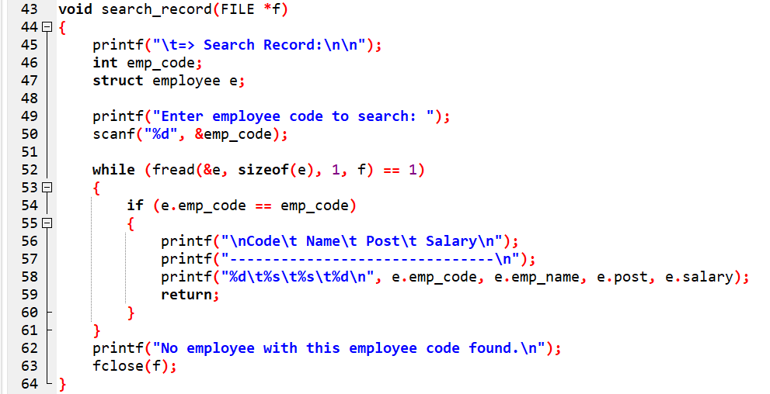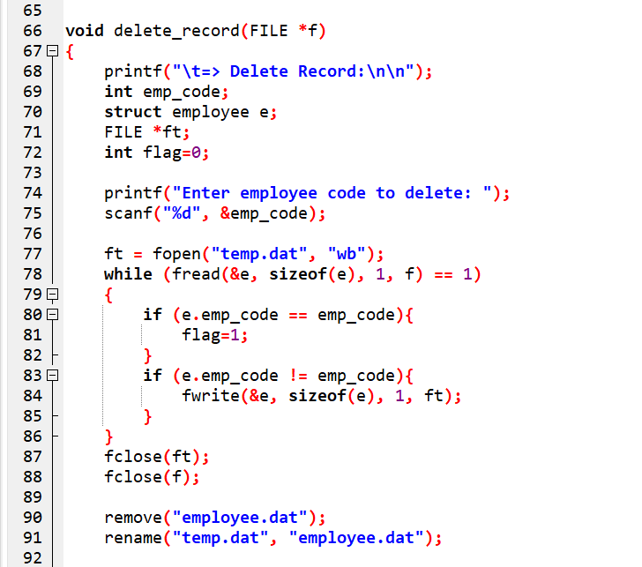

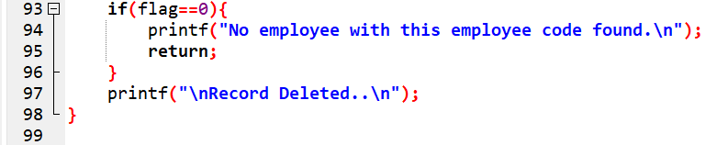

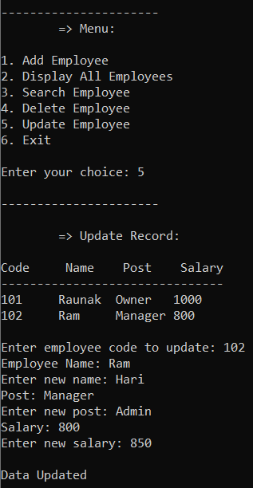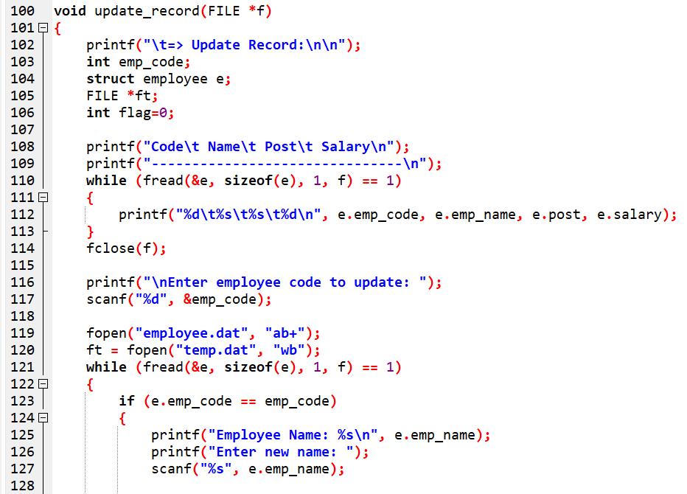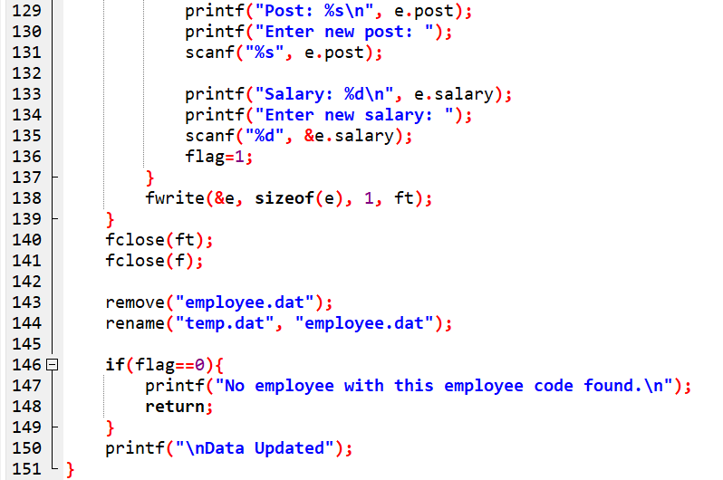

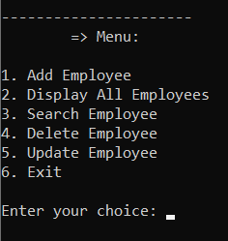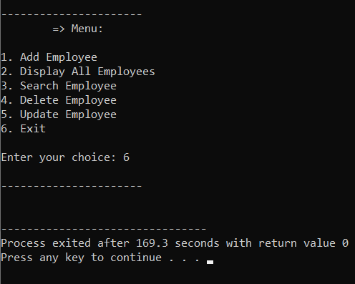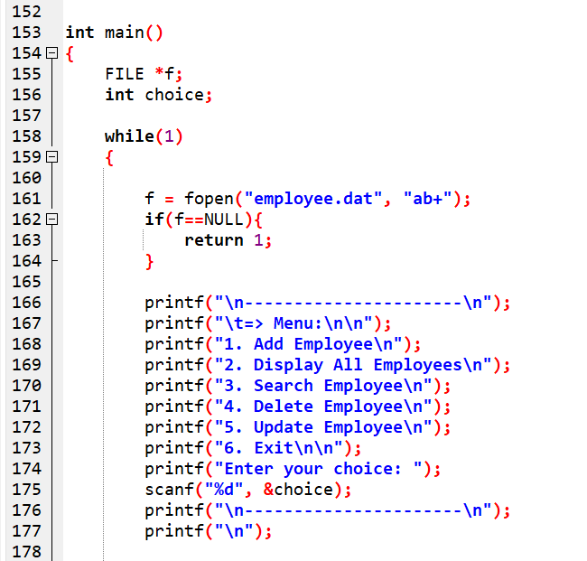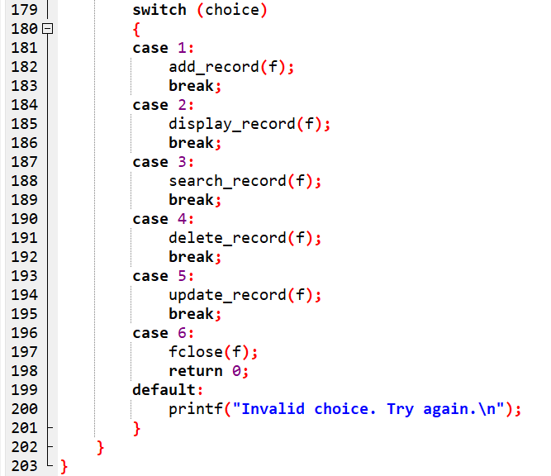

**Conclusion:**

I would like to thank Mr.Suresh Sir for giving us this wonderful opportunity to endure our skills on this project Data File Management through Programming. I have learned a lot from this assessment.

-Thank you…